Escaping the Echo Chamber: Finding Netflix Content on Your Own Terms

Jon K. Jacobson
Bellevue University
DSC640 T301 2257: Data Presentation and Visualization
Dr. Ben Schneider
June 14 20, 2025

Audience
I wanted to focus on an audience that is curious about content recommendations. This could include people who find it eerie that Netflix makes such good recommendations for them, as well as anyone suspicious of algorithms because of other interactions they have had with them. I also wanted to capitalize on the everyday experience of feeling that you might be missing out on something.
For aspiring data scientists in my audience, I would provide technical details via my Jupyter notebook. However, I intentionally kept the code out of the blog to make this blog post more accessible.
Purpose
The primary purpose of this blog post is to get the audience to think outside of the confines of algorithmic content suggestions. In cliché terms, the goal is to get them to think for themselves. To this end, I provide a thought-provoking discussion of different scenarios where you might want something that Netflix would not normally recommend to you. A welcome extension of my basic call to action would be to go from thinking for yourself to using the data to create your own content recommendations.
Design
I chose a blogpost to pull the audience into a written narrative. I chose a variety of visuals to engage interest. I used contrasting colors to emphasize contrasting figures and subdued colors for an overall tone of thoughtfulness. I attempted to balance image size with the goal of keeping discussion alongside the related image on the same page. Overall, I tried to keep the visualizations simple so they would clearly illustrate each given point of my argument.
Ethical Considerations
While this is a casual format for this subject matter, the underlying ethical considerations with content generation are quite serious. It would be easy, even automatic, for content recommendation to provide a highly biased view into available content. The world view of the developers and testers could subtly prevent or obscures other kinds of experience. This reality makes a project like this one important.
To overcome the “lie-factor” that is present in most visualizations, I try to call attention to the fact my visualizations are supported by different types of data. For example, I use both views within the first 91 days and views while on the top ten. If I didn’t call attention to it, it would be possible to infer a connection that isn’t there.
Conclusion
In summary, I chose to write a blog post for aspiring data scientists and anyone feeling constrained by algorithmic content suggestions. I chose to do my analysis and visuals using Jupyter notebook and Python. I’m inspiring the audience to use the available data on their own to find options that they might not otherwise encounter. I chose a variety of visualizations to keep the presentation interesting. This project touches on ethical themes, by bringing to the forefront the possibility of content recommendations excluding critical content. While I use relatively benign use cases, the techniques and process underscore the need to supervise algorithms to prevent unethical bias.
Word Count: 499

Blog Post: Escaping the Echo Chamber: Finding Netflix Content on Your Own Terms
Netflix is designed to keep your focus. Its algorithms are carefully tuned to keep you plugged in, clicking on the next movie or show so that you stay engaged in the service. But what if you want to make your own choices? What if you want to come up with your own algorithm? Using some straightforward data science techniques, you can use Netflix’s own data to make recommendations for yourself. You may discover that Netflix knows your preferences inside and out, but you might also find something that Netflix would have never recommended. You won’t know unless you grab a hold of the data and see for yourself.
I dug in and can show you some things you might like to try. I’ll link my Jupyter notebook so you can follow along. Or you can just read the highlights here.
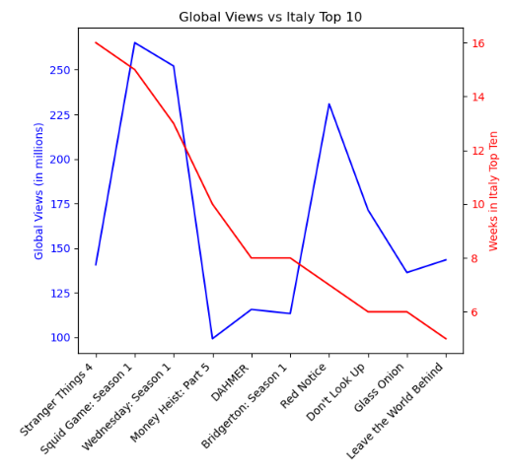
Say, for example, that you are traveling to another country and want to use Netflix content as potential conversation topics. How do you know whether the content you think is popular is also popular in that country? One way would be to look for titles that were in the top ten for that country the longest but are also in the top 20 most popular titles everywhere. We’ll use total views within the first 91 days as the criteria for the most popular movies. We will then then count how many weeks each title was in the top ten in that country to create our ranking. This is what we get for Italy:

It's worth noting that there isn’t much correlation between these two. If you’ve only been looking at globally popular content on your Netflix feed, you might have missed what was popular in Italy. However, if you’ve seen “Squid Games” (and there is a good chance you have) then that looks like it is still a good conversation topic in Italy.
But what if we want to prepare for our trip and watch something that is the most popular content in Italy, regardless of its popularity elsewhere? We can still use the weeks in the Italy Top 10 as the primary criteria, but we can leverage a different dataset that has content from the global top 10 by week. However, since we only views for titles that were globally popular, we are going to have some missing data if something was only popular in Italy:
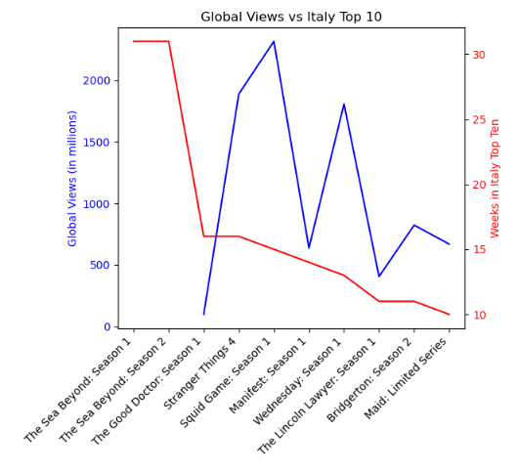
Based on this, before heading to Italy on your trip, it would probably be a good idea to do some homework and watch the “The Sea Beyond” series. No other title comes close. This happens to be an Italian series that is hugely successful in Italy but has not had much success outside of Italy. Even though it is not in the 2110 most popular titles provided by Netflix, it was obviously a huge hit in Italy. If you were stuck inside your Netflix algorithm, you might never have found this show!
You might have noticed that Netflix tends to recommend the most popular titles, but they turn this list over fast, so you are always looking at the latest and greatest. But what if you want to find titles that were popular for the longest? Maybe there is a title out there that wasn’t ever the biggest hit but stayed popular for a long time. Here are the top ten titles by the maximum time they were on the global top ten:
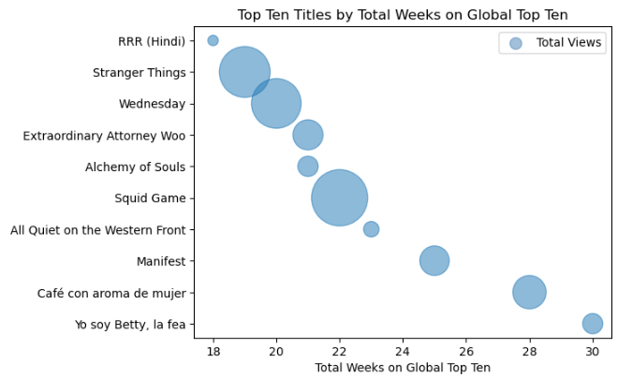
To illustrate the comparison in terms of total views, here are the views for the most viewed title against the title that was popular the longest. You can see that they are relatively close, but it is likely that Netflix hasn’t recommended the second one to you (certainly not as much as they recommend the first one).
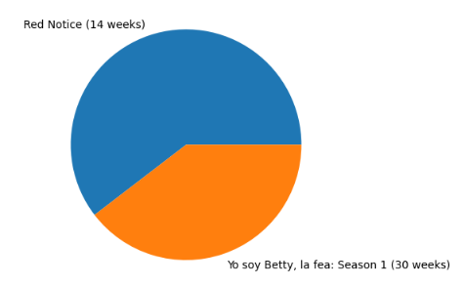
Another thing that Netflix prioritizes is what is most recent. But perhaps you were not watching Netflix during a portion of time, and you want to see what you missed. The data we have allows us to do this search, even though Netflix would probably never go back in time on your behalf.
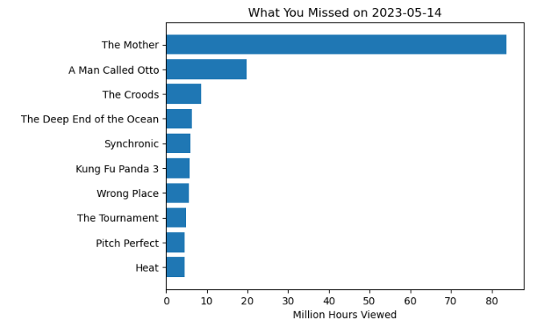

As one last example, Netflix tends to show you content that is popular in your country. But what if you want to look at what is popular everywhere else? In this case, we can exclude a country from the data to catch something we might otherwise miss. Here are the top ten such titles, sized by their average staying power in every country but the United States:

While it does take a little effort, I hope these examples show how it is possible to bend Netflix data to your own purposes and choose your next title from options that Netflix isn’t suggesting to you.

References
Netflix. (2024). All Weeks Countries [Data set]. Netflix.
Netflix. (2024). All Weeks Global [Data set]. Netflix.
Netflix. (2024). Most Popular [Data set]. Netflix.

